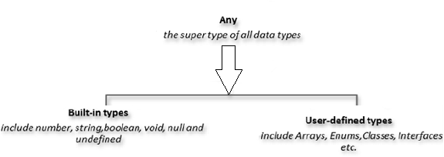

* **Any**

Dữ liệu có thể là bất kì kiểu gì

VD1:

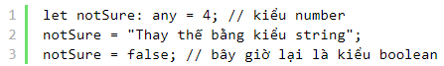

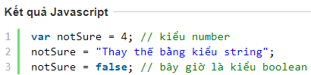

VD2:



* **Built-in Types (primitive)**

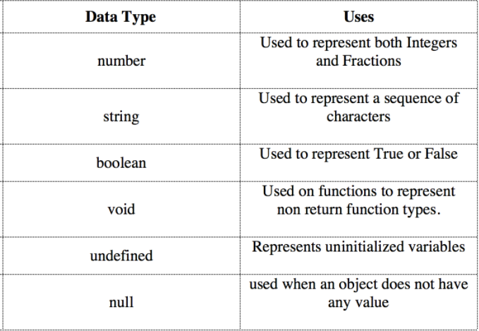

VD:

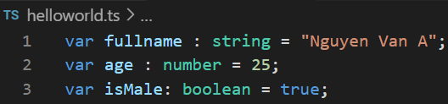

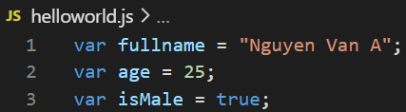

* + **Null & Undefined**

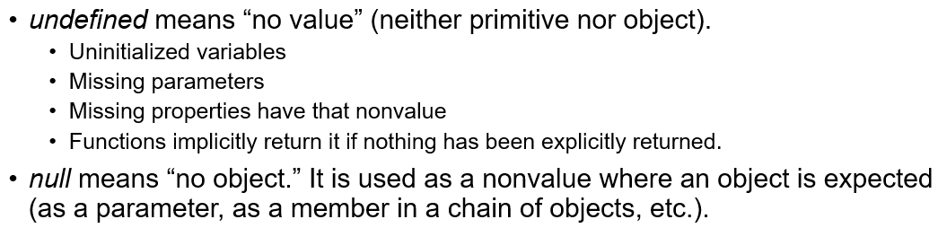

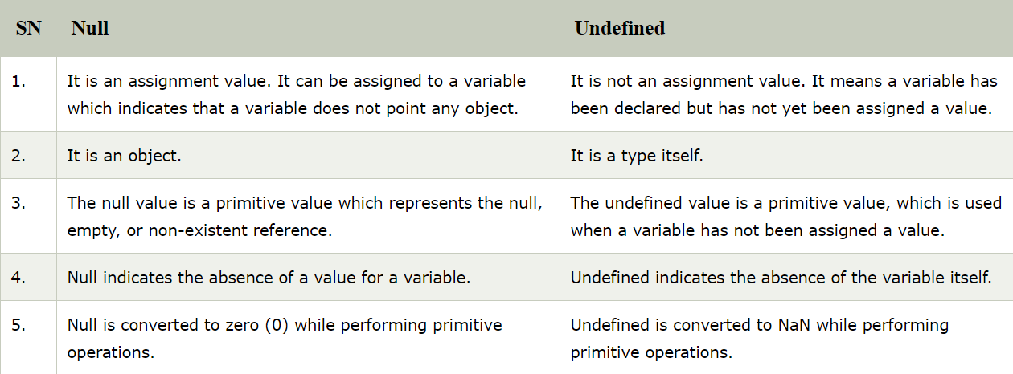

<https://www.javatpoint.com/null-vs-undefined>

* **Wrapper class**
* **User-defined Type (Object)**
  + **Array**
  + **Map**
  + **Set**
  + **Enum**
  + **Class**
* **Union datatype**



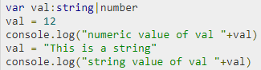

[*https://www.tutorialspoint.com/typescript/typescript_union.htm*](https://www.tutorialspoint.com/typescript/typescript_union.htm)

* **Check type of datatype**

Sử dụng variable, function **typeOf**





Đối với class thì sử dụng **instanceOf**

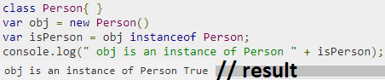

* **Convert datatype**



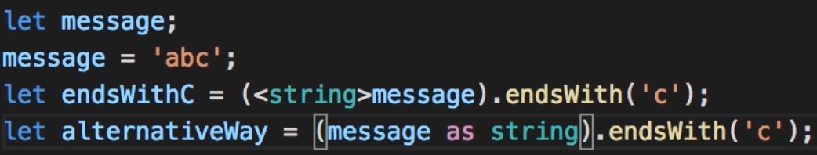

* **Reference**

<https://freetuts.net/typescript-basic-types-746.html>

<https://www.tutorialspoint.com/typescript/typescript_types.htm>

<https://www.javatpoint.com/typescript-types>